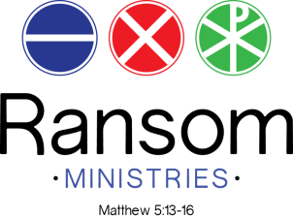

Dear Prospective Sponsor:
On February 1st, we will be participating in the 7th annual Charity Chase, a nonprofit 5K race for 10 Mobile-area charities. Participants select their charity when they register and then compete to win larger donations based on their performance. Additionally, we are able to significantly increase how much funds are raised by recruiting our own sponsors. 100% of your sponsorship goes directly to our organization. Though your donation would go to us, you would still be considered a full race sponsor with the opportunity to have your logo hyper linked on the event website (www.TheCharityChase.com), and included in the post-race email as well as on our website and promoted through our social media accounts. You could also receive recognition on race day and be able to promote your organization with a booth, banners along the race course, and more upon request depending on the level of sponsorship you choose.
As a sponsor for 2020 Charity Chase, your organization can partner with us in our mission to empower people to overcome spiritual, relational, and material poverty through knowing Jesus and using their God-given gifts and talents in their work. Ransom Ministries believes following Jesus can break the cycles of poverty and transform individuals, families, communities, and the world. Details on sponsorship levels and how to submit your contributions are enclosed. We appreciate your consideration and would be happy to answer any questions you may have.
Sincerely,
Tara Armbruster
tara@ransomcafe.com
251.455.1525

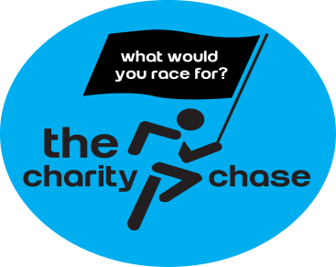
Run for Ransom at the 7th Annual Charity Chase
For the last 6 years, The Charity Chase has been Mobile’s premier joint-charity fundraiser. It is a crowd-sourced platform for local nonprofits to raise funds, increase awareness, and build excitement without the financial risks or time commitment to host their own race. It is a truly unique race that unites local charities in one event showcasing the incredible philanthropic spirit present in our Port City.

Sponsorship Levels
Sponsorship Level | Tax-Deductible Donation | Sponsorship Description
Hall of Fame | $5000 | - Donation made directly to Ransom Ministries  - 5 complementary race entries  - Company logo hyperlinked on event website, post-race email, and on Ransom Ministries website  - Opportunity to advertise on race course, water station, and at finish line with company banners  - Recognition on Ransom’s social media  - Race day recognition
MVP | $2500 | - Donation made directly to Ransom Ministries  - 4 complementary race entries  - Company logo hyperlinked on event website and post-race email  - Recognition on Ransom’s social media  - Race day recognition
All-Star | $1000 | - Donation made directly to Ransom Ministries  - 3 complementary race entries  - Company logo hyperlinked on event website and post-race email  - Recognition on Ransom’s social media  - Race day recognition
Captain | $500 | - Donation made directly to Ransom Ministries  - 2 complementary race entries  - Race day recognition
Sponsorship Commitment
Partnership Level:
Yes! We would like to partner with Ransom Ministries by sponsoring you for The Charity Chase. We choose the following sponsorship level (please check one):
- Hall of Fame ($5,000)
- MVP ($2,500)
- All-Star ($1,000)
- Captain ($500)
- Other (______)

Contact Information:
Business/Organization Name: __________________________________
Prefer to stay anonymous? (circle one): Yes No
Primary Contact: _________________________________________
Phone: _______________________________________________
Email: ______________________________________________
Website: ______________________________________________

Submission & Payment:
Submission:
Please email your logo and preferred website for hyper linking to tara@ransomministries.com. Please indicate your selected sponsorship level. Logos must be sent to Ransom 4 weeks in advance to guarantee inclusion on the event shirt.
Payment:
Please make the checks payable to Ransom Ministries and mail with this page to the address below. If you prefer to make an online submission, you may email this form to us at tara@ransomministries.com and make your donation online (https://ransomministries.networkforgood.com/projects/86591-year-end-giving).
Ransom Ministries P.O. Box 851854 Mobile, AL 36685
RansomMinistries.com

